Week-3 Demo Report

There are Five Scenarios assigned to be Done So I Created 5 feature files for 5 Scenarios
5 Feature Files Based on task
Task – 1 : EtoEFlow.feature
Task – 2 : cartbadge.feature
Task – 3 : severalProducts.feature
Task – 4 : FreshCart.feature
Task – 5 : negative.feature

Structure I used in the Project:

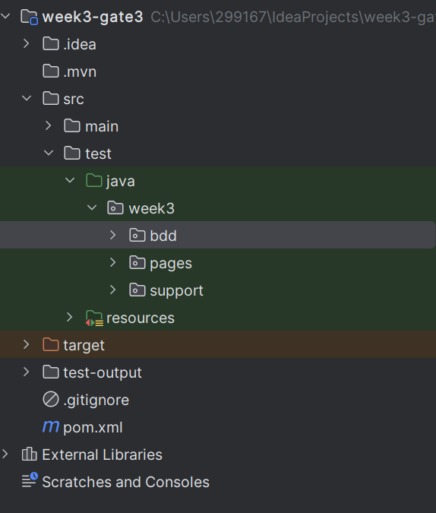
Task – 1 : End to End Flow
In this I done with two flows I is with login and Other one is without Login.
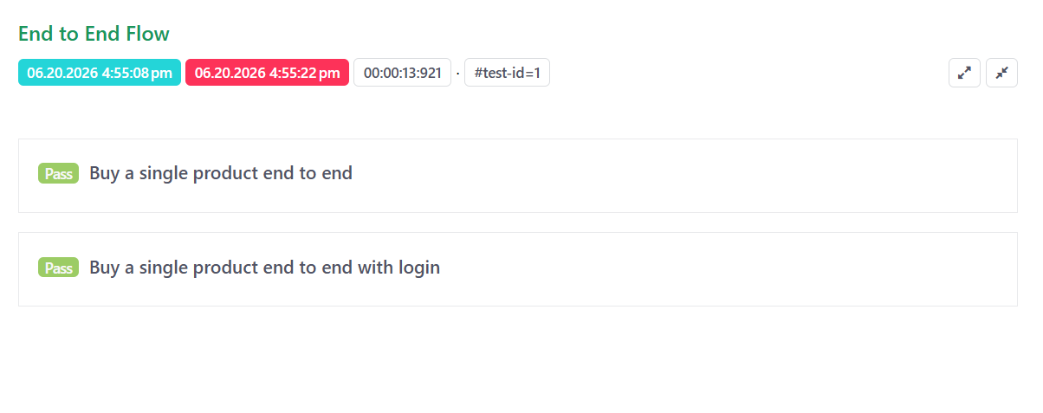
The Above pic shows the result report of the Following End To End Flow Task

Task – 2 :
Cart Badge Reflects the number of items added.
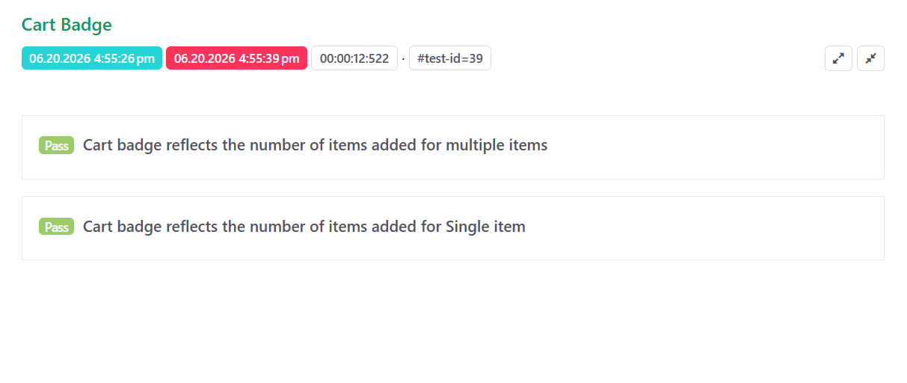
The Above Shows the Result Report for the following task Cart Badge.

Task – 3 :
Buy across Several Products across same Scenario.
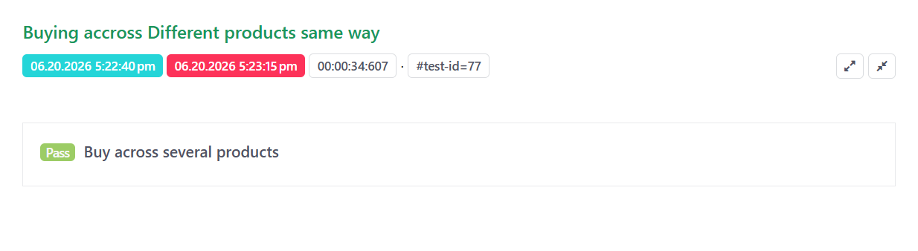
The Above Shows the Result Report for the following Buying different Products in the same Way.

Task – 4 :
A fresh Cart is empty.
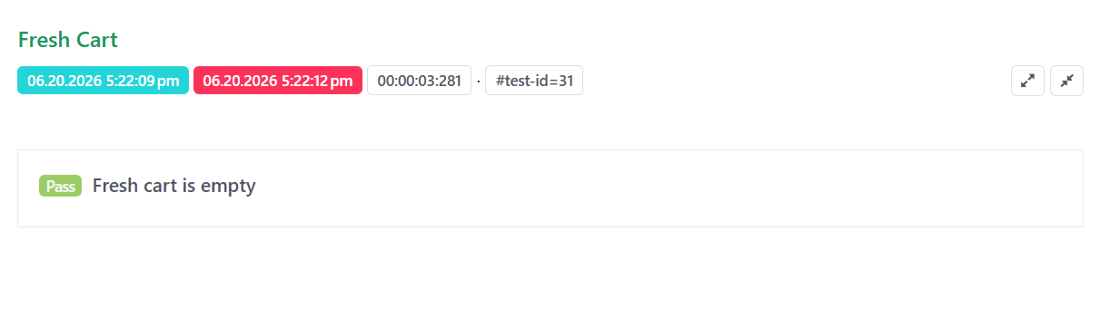

The Above Shows the Result Report for the following Fresh Cart.

Task – 5 :
One deliberately faling scenario to demonstrate the failing ScreenShots.
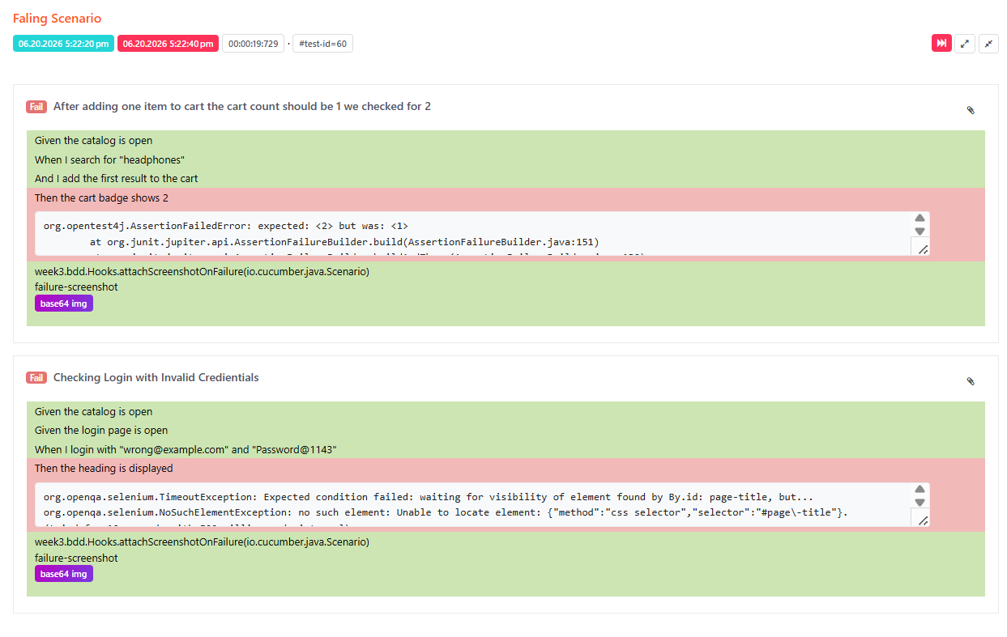
Failing ScreenShots:
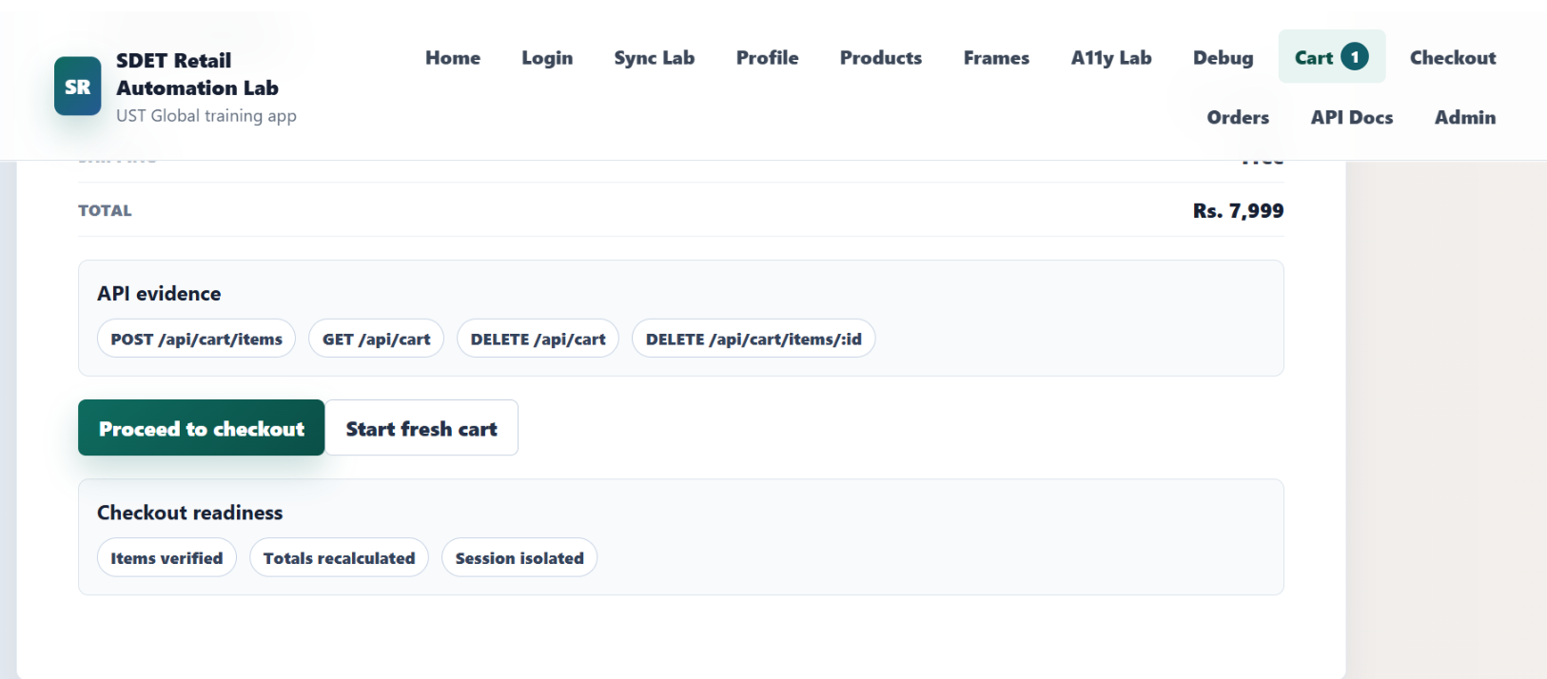

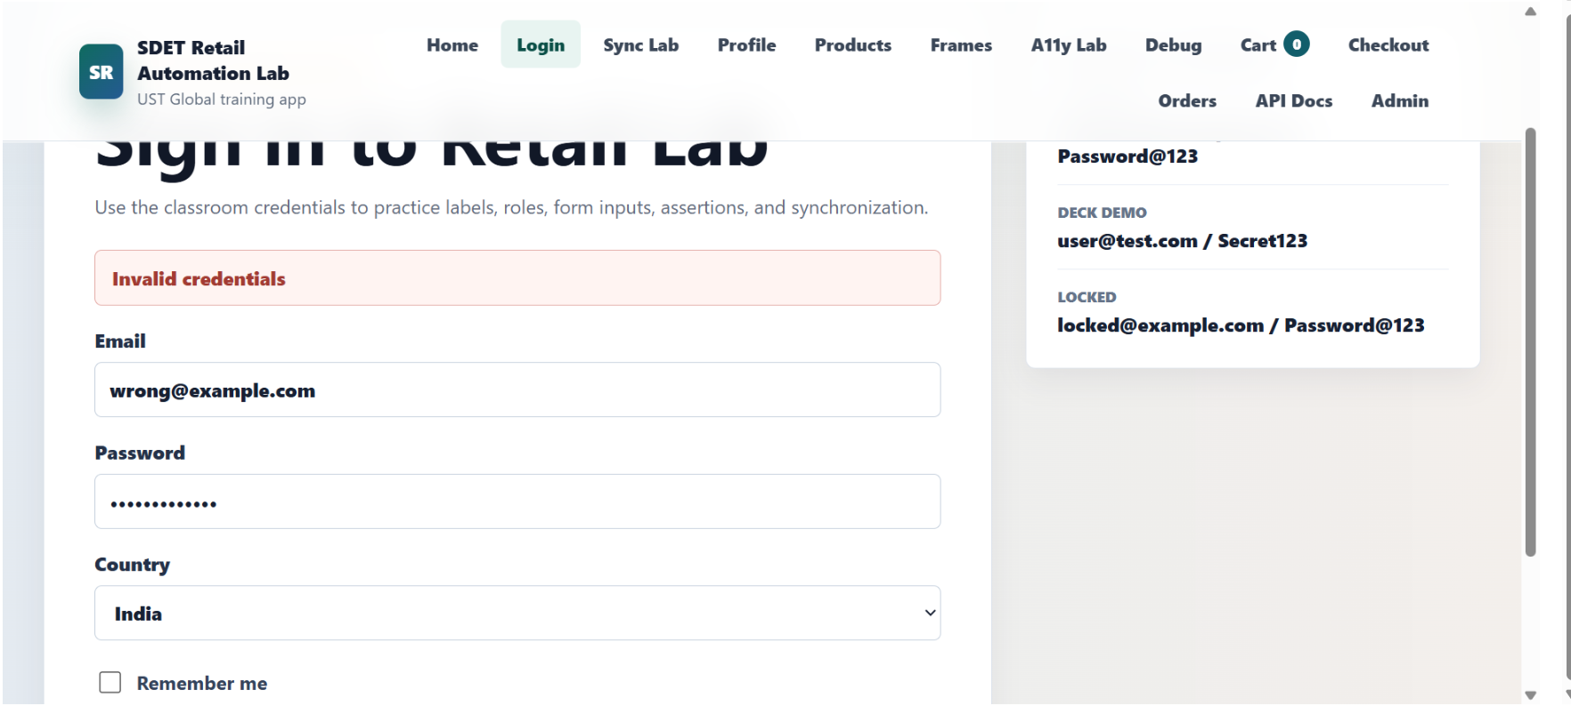

The Above was the report and the failing Screenshots for the last Task-5.
Why Tests failed in task -5:
1.one task is for I added one product in the cart the cart count should be 1 but I checked for the cart count 2.
2.The Second task failed because I checked for the login successful by giving incorrect credentials in the login.

Now I will Give instructions to how to run the project.
1. First we need to add required Dependencies in the pom.xml file.
2. The we need to give the following command to run all the tests together
mvn -Dtest=RunCucumberTest "-Dcucumber.filter.tags=@smoke or @regression or @exercise or @negative" test
if you want to run individual tasks like smoke,regression,exercise or negative use the following commands in the terminal
for smoke test
mvn -Dtest=RunCucumberTest "-Dcucumber.filter.tags=@smoke" test
for regression test
mvn -Dtest=RunCucumberTest "-Dcucumber.filter.tags=@regression" test
for negative test
mvn -Dtest=RunCucumberTest "-Dcucumber.filter.tags=@negative" test

I mentioned the logic for feature files in week3/bdd
Since I separated all the feature files The RunCucumberTest.java file should be
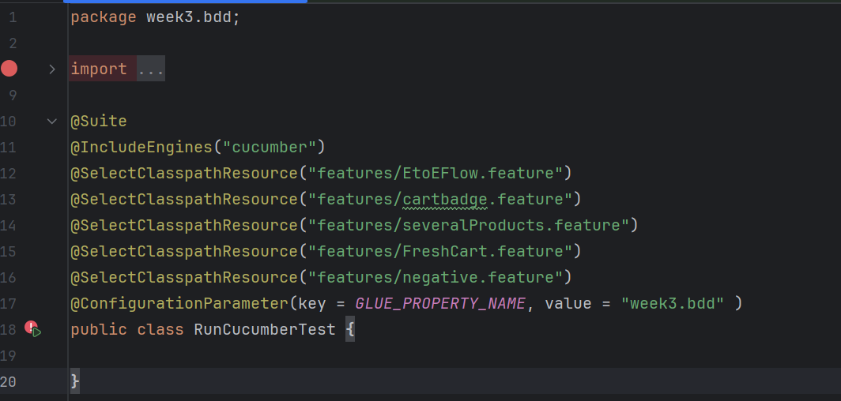

You can also see the SparkReport in test-output
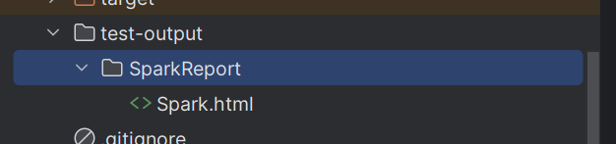
And also You can see the allure-results in json format in target/allure-results
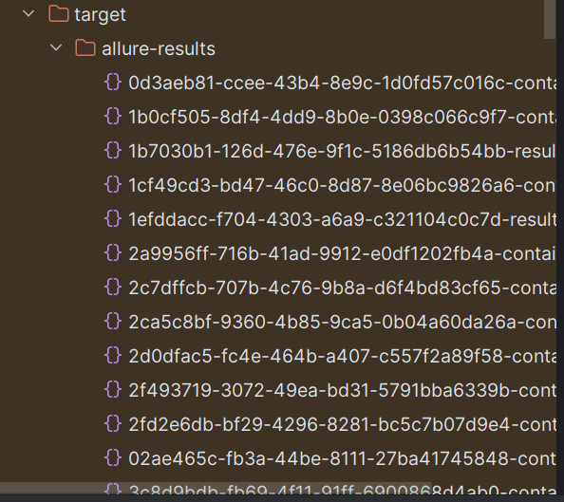

How to Run the Project
Run all tests:
mvn clean test
Run in headed mode:
mvn clean test -Dheadless=false
Run smoke tests only:
mvn clean test -Dcucumber.filter.tags="@smoke"
Run regression tests:
mvn clean test -Dcucumber.filter.tags="@regression"
Run end-to-end tests:
mvn clean test -Dcucumber.filter.tags="@e2e"
Run negative scenario:
mvn clean test -Dcucumber.filter.tags="@negative"
Run multiple tags:
mvn clean test -Dcucumber.filter.tags="@smoke or @e2e"

Screenshots :
